# **Site plan**

**Site purpose:**

The purpose of this temple inn and suites is to inform customers about where travelers can seek lodging, and usually, food and drink. This also includes providing specialized service and accommodations that meet the needs of those patrons. These hotel accommodations and services are available to anyone willing to abide by the terms and policies outlined by our company.

**Target Audience:**

Our company is committed to serve customers and the community as a whole.

Personas:

* Persons over the ages of 18 years.
* Members of the church of Jesus Christ of Latter Day Saint
* Non – members ( who have the desire to learn about the gospel)
* Non – Alcoholics and smokers

Schedule an appointment with us. Our company cares for the safety of individuals, Companies and online businesses. Kindly give us a call now. Thanks

**Site Map**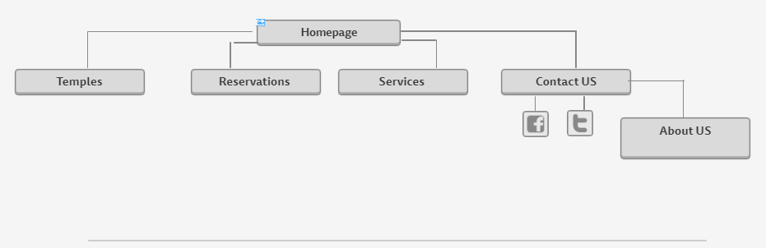

**Color Scheme:**

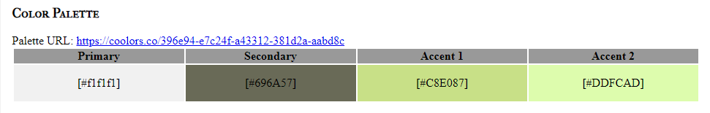

**Topography:**

Typography

Heading Font: Times New Roman

is appropriate for reading plain texts such as contracts and for that purpose, it uses space economically – nothing more, nothing less. Legibility and economy of space. The two characteristics “legibility” and “economy of space” interact. Legibility is a term of art

Paragraph Font: Arial

Arial will certainly work in more cases than any font-face, and of course, any media type. On top of that, most users won't need to load additional files, so it means less requests , more speed and arguably more elegant code. In short: consistency, speed, coverage.

**Wireframes:**

Desktop view

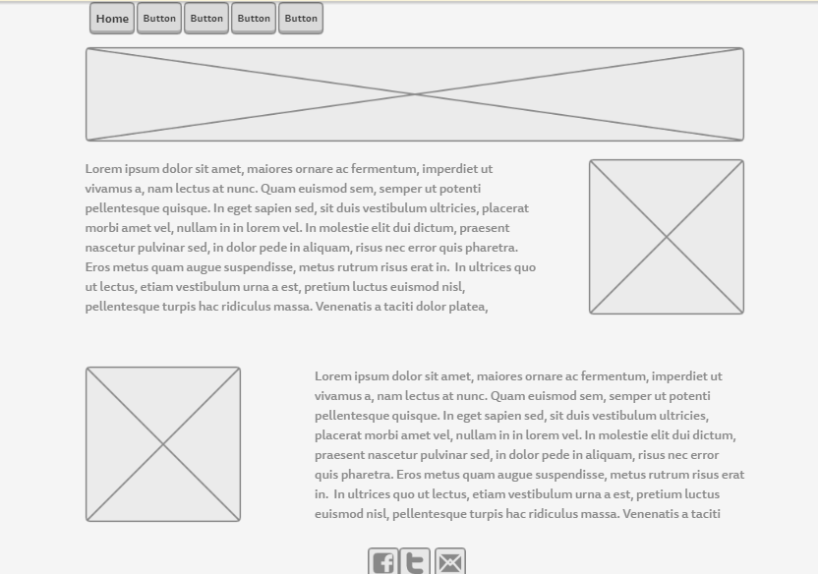

Mobile View

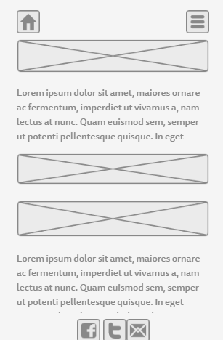

Medium View

